# Game Desing English

Dino Museum VR

Cristian David Jaramillo Calle

Group: 1319447

Víctor Hugo Cardona

(Instructor)

SERVICIO NACIONAL DE APRENDIZAJE

Centro de servicios y gestión empresarial

Industrias creativas

Medellín

2018

**SECTION 1 – SUMMARY OF THE VIDEO GAME.**

**HIGH CONCEPT.**

**EXPLORE AND ANCIENT WORLD.**

Dino Museum VR is a educational game where the main protagonist is you and you are inside of a musum, where you can learn about of the dinosaurs who lived in our planet.

**CHARACTERISTICS.**

Principal characteristics:

* Explore a museum where you can learn with the dinosaurs in the game.
* The game is intended for devices with the Android operating system and make use of virtual reality.
* The video game makes use of virtual reality glasses since these glasses have a button so you can interact with the movement, the output device will be the interaction with the environment and the graphical and informative section.

**GENRE:**

The game belongs to educational games, these games are based on displaying information where the player can learn.

**TARGET AUDIENCE.**

The game is E for everyone, any person play the game.



**VISUAL STYLE**

The graphic style of the game is made up of 3D models, its type of camera is free since the user can move in any direction where the points are to move and can rotate in any direction.

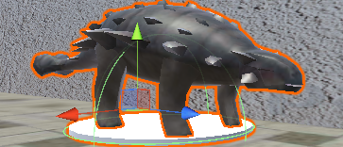

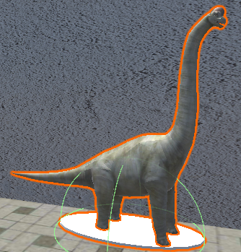

*Thanks to* [*3dregenerator*](https://free3d.com/3d-models/?author=3dregenerator) *for the free models*

**SCOPE OF THE PROJECT.**

At the end of the development of the game it is planned to deliver everything complete, a museum where the player can see the different dinosaurs and can move, likewise make the publication on [Medium](https://medium.com/@cristian.chuntaco/dino-museum-vr-8db9979765dc) so that other people have access to it.

**SECTION 2 – HISTORY, ENVIROMENT AND CHARACTERS:**

The characters of the game are the dinosaurs, this are 3D models where they are just turning to appreciate them.

**DINOSAURS:**

**Ankylosaurus**

Found in: North america.

Measurements: 7 mts long x 1.8 mts high.

Weight: 4.5 tons

Diet: Herbivorous

Years: 74-67 millions years ago

**Brachiosarus**

Found in: USA, Portugal, etc

Measurements: 30 mts high x 23 mts long.

Weight: 35 to 90 tons

Diet: Herbivorous

Years: 152-145 millions years ago

**Gallimimus**

Found in: Mongolia

Measurements: 6 mts

Weight: 440 KG

Diet: Omnivore

Years: 70 millions years ago

**Pachycephalosaurus**

Found in: North America

Measurements: 25 cm of thickness of his skull, 5 mts high

Weight: 2 tons

Diet: Omnivore

Years: 70-66 millions years ago

**Spinosaurus**

Found in: North of Africa

Measurements: 18 mts high x 5 mts long

Weight: 8.5 tons

Diet: Carnivorous

Years: 112-97 millions years ago

**Tyrannosaurus Rex (T-Rex)**

Found in: North America

Measurements: 4 mts high x 12 mts long

Weight: 6 tons

Diet: Carnivorous

Years: 65 millions years ago

**Triceratops**

Found in: USA

Measurements: 9 mts high x 3 mts long

Weight: 10 tons

Diet: Herbivorous

Years: 70-65 millions years ago

**Velociraptor**

Found in: Mongolia

Measurements: 1.8 mts long x 2 mts high

Weight: 60 KG

Diet: Carnivorous

Years: 80 millions years ago

**HISTORY AND NARRATIVE**

Dino Museum VR consists in explaining to the player the history of several of the dinosaurs that populated our planet, likewise giving information data about them, such as their weight, what they ate, measurements etc.

**NARRATIVE DESING**

It will be counted by means of pictures in the museum where the player will be able to read them without problem and to see models of the dinosaurs to know how they were.

**SECTION 3 – GAMEPLAY AND MECHANICS OF THE VIDEO GAME**

The player has control over himself to move around in the museum interacting with the button that the virtual reality glasses have.

**OBJECTIVES**

The objective of Dino Museum VR is that the player acquires knowledge about what was explained in the museum.

**MECHANICS**

The mechanics are simple, the player can rotate 360 degrees using the virtual reality glasses, so he can move in any direction by means of specific points on the map.

**PHYSICS**

The player to be playing will have a pointer which when touching a sphere this will get bigger, meaning that you can move to this place.

**MOVEMENTS**

The player can move to any of the specific points that are in the museum, can rotate in any direction and can interact with the texts.

**OBJECTS**

It will feature 3D dinosaur modeling and information so that the player can learn about them.

**SECTION 4 – LEVELS**

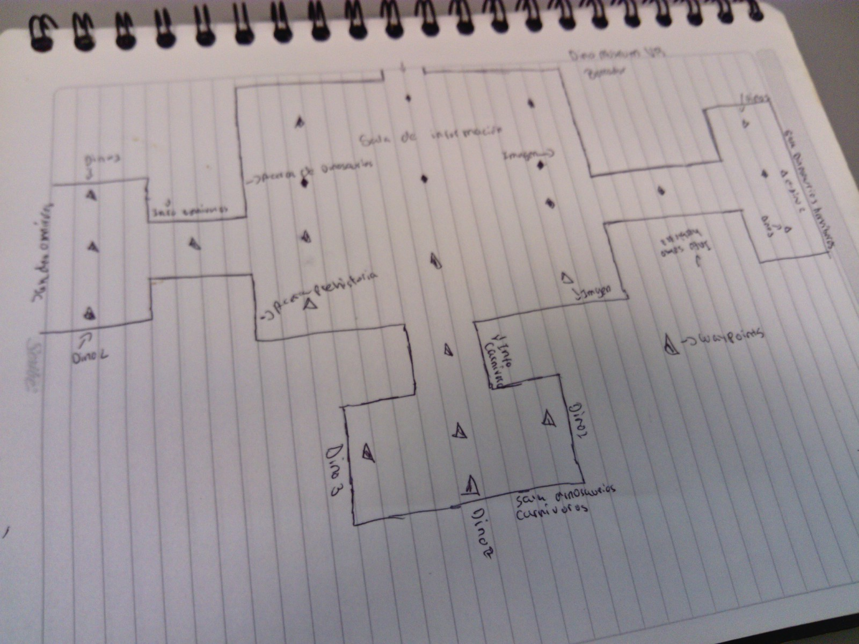

**ENVIROMENT**

The player is in a museum where he can move to specific points, in this museum the player will see dinosaurs where he can find out about them.

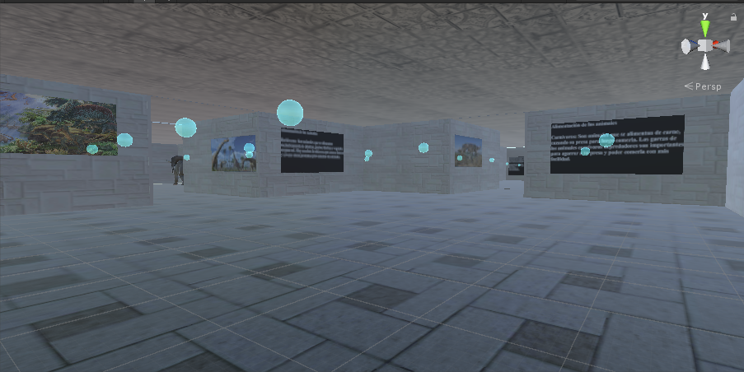

**SECTION 5 – INTERFACES**

**GRAPHICAL USER INTERFACES**

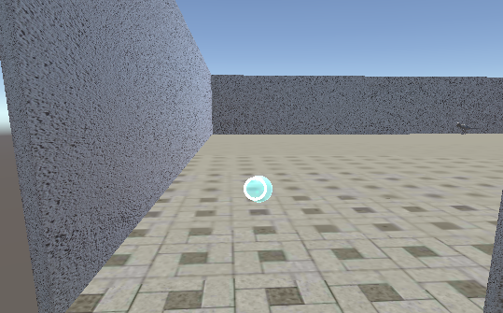

**ENTRY DEVICE**

The input device is the Smartphone since this is the one that will make the application run and show on the screen all the video game and the Cardboard or virtual reality glasses (VR) will make the player to put them can interact with the game.

**SOUNDS**

There are many SFX sounds for the dinosaurs, credits to the user [**jarredgibb**](https://freesound.org/people/JarredGibb/) for the sounds

**SECTION 6 – TECHNICAL ASPECTS**

Dino Museum VR is for Android platform with Android 4.4.4 or above.

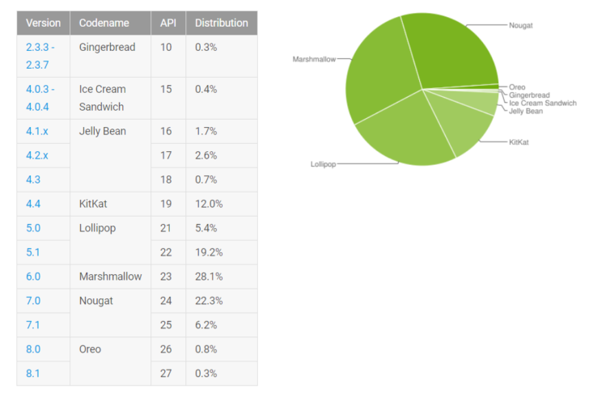

*Data extracted in the month of February 2018*

**DEVELOPMENT HARDWARE AND SOFTWARE**

|  |  |
| --- | --- |
| Component | Model |
| Processor | Intel Core i7-2600 @3.40GHz |
| RAM | 8GB DDR3 |
| Motherboard | Dell 0Y2MRG |
| Display | Dell LCD 22’ |
| Peripherals | Mouse, keyboard, googles VR |
| Hard drive disk | 1.36TB |
| Graphic card | AMD Radeon HD 6450 1GB |
| Operating System (OS/SO) | Windows 7 Professional SP1 |
| Game engine | Unity 5.6 |

**SECTION 7 – DEAL**

**MONETIZATION**

Is a free game and only for educational use.

**PLATFORM**

The platform where a publication will be made will be by Medium disclosing our project and can be tested by any non-profit person also is saved on GitHub.